

0

Experience A Fun Format, Great Payout & Support A Good Cause!

Saturday, January 25th @ 1:00pm
@ Bowlero Kyrene
6225 W Chandler Blvd, Chandler

Entry Fee: $100 per team CASH ONLY
12 Strikes
$2000
300 game
$142
Two Divisions: 430 Average or 370 Average Cap

Average is based off:(in this order)
- 2023-2024 Standard Composite with 21 games minimum
    - if your current league average is 20 pins higher than your 23/24 composite you must report it
- Highest Current season league average
- 2022-2023 Standard Composite with 21 games minimum
- Strike Force Tour current converted to house
- If none of the above apply, average will be 220

- Pre register or walk in. Walk in's are always welcomed, depending upon lane availability
- Pre register by commenting or sending message through our Facebook page @ TBT: Thompson Bowling Tournaments or email mesastrikers@q.com
Round 1 side pots:
High Games: $12/team
~
High Series:
$6/team
~
300 game $2/team
(2 win - they split
3 or more - rolls over)
~
12 strikes $2/team
(2 win – they split
3 or more - rolls over)

All Side Pots are 1st round only
- Guarantee your spot ~ we offer a prepay option through Venmo, let us know if you're interested and we'll message you the details
- Entries accepted first come first serve. You will receive a confirmation reply or email with your total entry fee, and check in details
- One member of the registered team, must arrive to check in by 12:30pm, in order to keep your spot. Starting at 12:30pm we will open up to our waiting list

Format
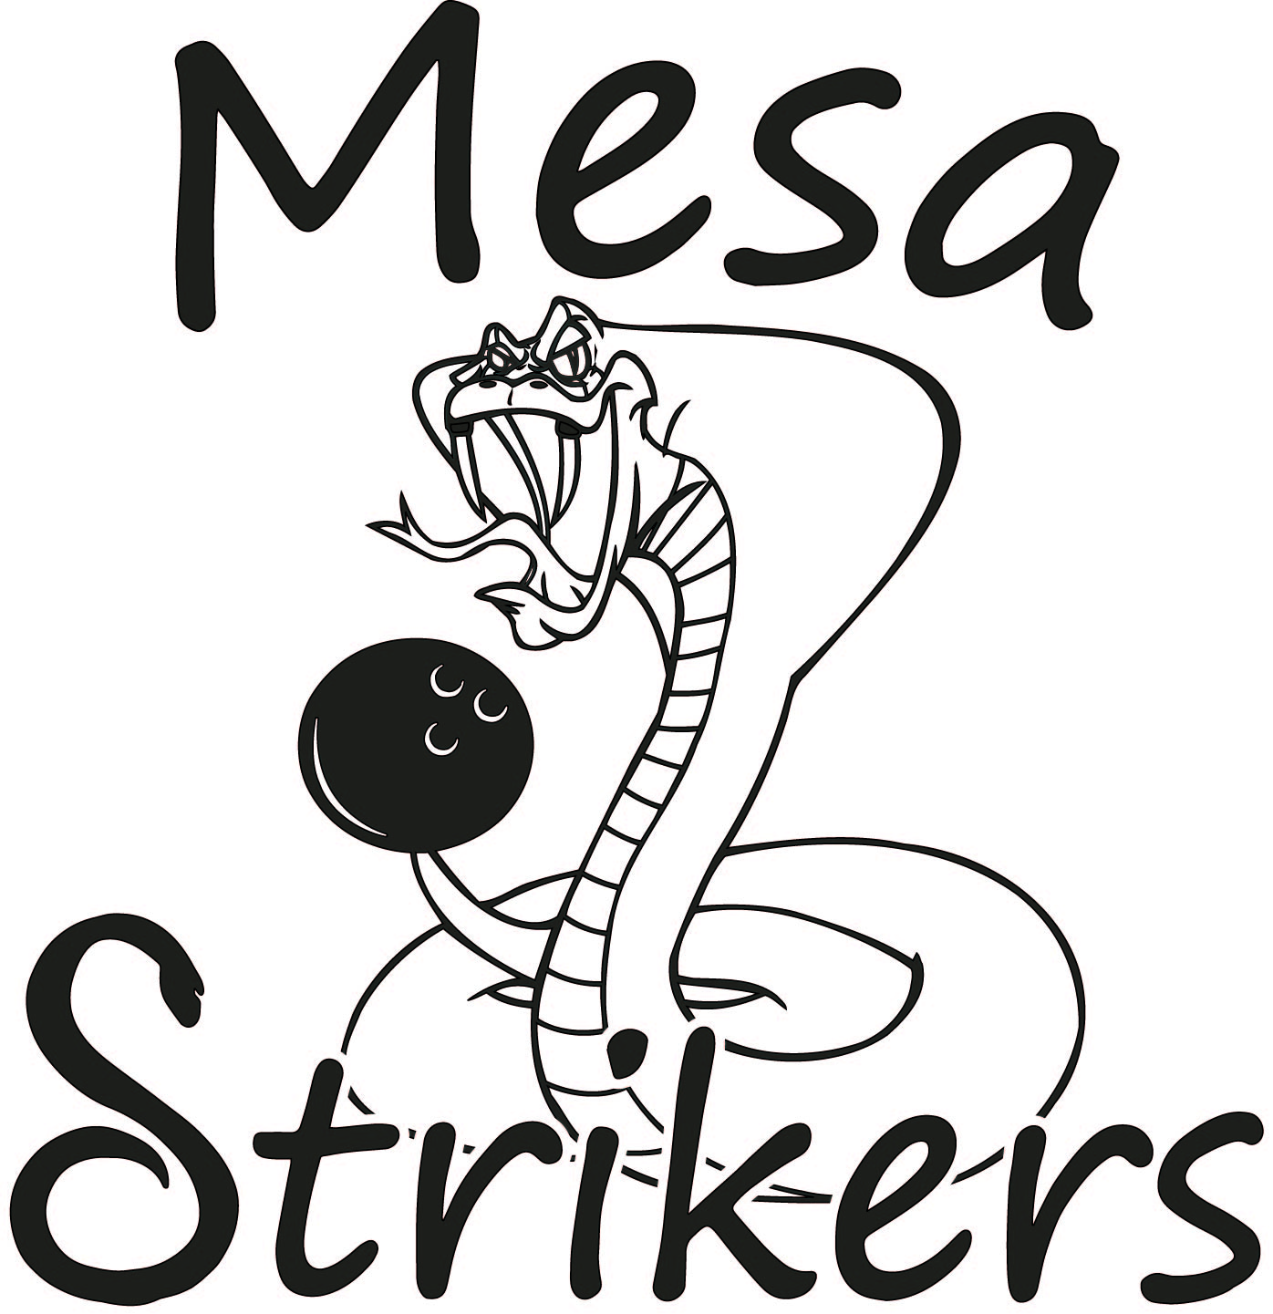
Round 1 – 6 games of bakers (cut in half)
Round 2 – Drop Scores, 3 games bakers (cut in half)
Round 3 – Drop Scores, 1 game baker scoring (cut in half)
until final 2 teams bowl for Champion

Follow TBT: Thompson Bowling Tournament on facebook



Follow TBT: Thompson Bowling Tournaments on Facebook or Instragram
TBT: Bakers Doubles Tournament Rules:
- Open to ALL men & women
- This is a scratch tournament, zero handicap will be given
- Averages are pulled in this order:
  - composite average from 2023-2024 with 21 game minimum
    - if your current league average is 20 pins higher than your 23/24 composite you must report it
  - highest current league average (must bring current league standings sheet)
  - composite average from 2022-2023 with 21 game minimum
  - SFT converted to house
  - if no average appears on bowl.com or current league you will bowl scratch, 220
- Averages will update every September. This will allow summer leagues to be included in the composite
- Reporting of bowler averages is the sole responsibility of the bowler. Failure to give the correct average may result in an average re-rate or possible disqualification. Once event has begun, there will be no refunds
- Round 1:
10 minutes of practice
Bowl 6 games of bakers doubles across 6 pair of lanes. Teams will alternate frames bowled
After completion of 6 games, the field will be cut in half
In the event of a tie for the final spot – a 9th & 10th frame roll off will determine who will advance
If still a tie after roll off, sudden death* will determine who advances
No scores roll over
- Round 2:
No practice will be between round 1 & 2
Bowl 3 games of bakers doubles across 3 pair of lanes
After completion of 3 games, the field will be cut in half
In the event of a tie for the final spot – a 9th & 10th frame roll off will determine who will advance
If still a tie after roll off, sudden death* will determine who advances
No scores roll over
- Round 3:
Cashing rounds – if you make it to round 3, you will leave with prize money
single game elimination cutting the field in half until we are down to two teams bowling one final round to determine the champion
In the event of a tie for cut, a 9th & 10th frame roll off will determine who moves on
If still tie after roll off, sudden death* will determine winner
Once cut has been determined. Any placement other than 1st & 2nd will split prize
- Any team knowingly reporting the wrong scores, will be immediately disqualified and placed on 1 year suspension. 2nd offense will result in permanent suspension from future events.
- Optional side pots will be available for round 1 only
- THIS IS NOT A USBC CERTIFIED TOURNAMENT. However, we do follow USBC guidelines. Here are a few of the most common:
  - 8/1/20 – all holes in ball must be used
  - Once competition has begun, there is no resurfacing bowling balls
  - Purple Hammers with serial numbers starting 6 or 7 will not be allowed
  - Storm Spectre will not be allowed
- Entry fee will be $100.00/team CASH ONLY, day of or prepayment through Venmo
- Prize fund will be paid out at the conclusion of the tournament. Any unclaimed prize fund will be donated to Mesa Strikers Youth League
- All decisions made by the tournament director are final. Tournament director has the right to deny any entry, re-rate any bowler and disqualify any bowler if necessary.

*Sudden death:
Each team will roll one ball, the team with highest pin fall wins
Each team will decide who throws the shot, and which lane they are using
If tie remains, the other team mates will each roll one ball on the opposite lane as the first
This will continue until winner is determined

